Combined Band Dendrometer Protocol
ForestGEO / CTFS Global Forest Carbon Research Initiative

Version: August 6, 2017

Helene C. Muller-Landau
mullerh@si.edu

Materials needed
- Diameter measuring tape (1 per person)
- Wooden stick 1.4 m long, with marks at 1.0, 1.1, 1.2, 1.3 and 1.4 m (1 per person)
- Ladder (1 per team)
- Clipboard and datasheets (1 per person)
- Permanent marker (1 per person)
- Tree marking paint, either in a small container with a brush built into the lid (as used for glue) or as spray paint (1 per person)
- Snips/heavy-duty scissors (1 per person)
- Digital calipers (1 per person)
- For metal dendrometers:
  - Stainless steel banding (for each tree, a length equal to the circumference plus ~10 cm; details below)
  - Heavy-duty level hole punch (1 per person)
  - Stainless steel springs (1 per tree; length of 38 or 76 mm depending on tree size – see below)
- For plastic dendrometers:
  - Plastic banding (1 per tree, length depending on tree size- see below)
  - Seals (2 per tree)
  - Seal tightener compatible with banding and seals (1 per person)
  - Stainless steel springs (1 per tree; see below)
- Optional: Binoculars, to improve estimation of liana load (1 per person)

Dendrometer installation

Tree Status Observations
- Locate the designated tree.
- If the tree is dead or presumed dead (missing), record this under notes using the usual plot codes. In the absence of local plot codes, plot codes for BCI are recommended. These begin with D for “Dead”:
DS = Dead trunk still standing
DC = Dead trunk lying on ground
DT = Tree missing, tag found
DN = Both tag and tree missing
- Examine the stature and condition of the tree; record any special cases under “Notes” on the datasheet. Relevant standard plot codes for BCI are as follows; also record if there are “thorns”:
M = multiple stems
R = stem is a resprout from a break below 1.3 m
Q = stem broken above 1.3 m
B = buttresses extending to 1 m or higher
I = irregular stem
L = stem leaning

- Assess and record the crown condition of the tree using either the 4-point crown condition scale below or the % branch scale from the mortality census, as determined by site preferences and field team experience.
  - The 4-point crown condition scale has the following categories:
4 = 75-100% of the crown is intact (no or few branches lost)
3 = 50-75% of the crown is intact
2 = 25-50% of the crown is intact
1 = 0-25% of the crown is intact (most of the crown is gone)
  - OR the mortality based % branch scale follows:

This refers to all the woody biomass connected laterally to the living part of the stem, above the POM. In large trees the branches tend to form crowns, in small trees they often don’t.  In the diagram, the empty spaces correspond to dead branches that can remain there (dead) or that may be recently gone. We are not considering branches that disappeared so long ago that the scar doesn’t leave inner wood exposed.  Note: it is sometimes difficult to distinguish dead branches from living branches without leaves. Usually living branches show abundant twigs (small terminal branches) that are usually absent from dead branches.  Some species have naturally sparse and open crowns with very few branches (e.g. Cecropia), allowing much light to go through. Do not consider that as branch loss. | 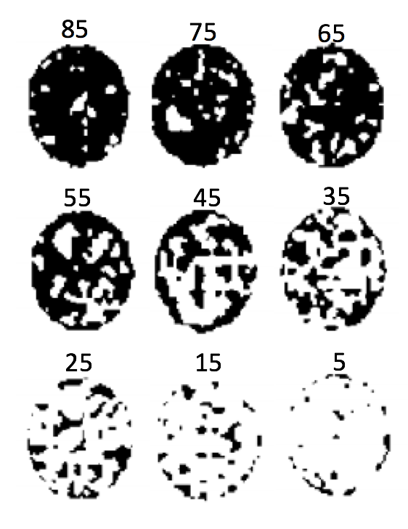  Figure 1. Examples of different proportions of branches remaining.

- Assess and record the crown illumination index (CII) of the tree. The different values are defined as follows (see Figure 2; note that lianas do not impact this illumination index):
5 = crown completely exposed (to vertical light and to lateral light within the 90 degree inverted cone encompassing the crown)
4 = full overhead light (>=90% of the vertical projection of the crown exposed to vertical light; later light blocked within some or all of the 90 degree inverted cone encompassing the crown)
3 = some overhead light (10-90% of the vertical project of the crown exposed to vertical light)
2 = lateral light (<10% of the vertical project of the crown exposed to vertical light; crown lit laterally)
1 = no direct light (crown not lit directly either vertically or laterally)
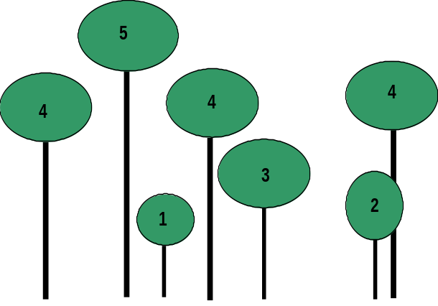
Figure 2. Examples of trees having different values of the crown illumination index.

- Assess and record infestation of the tree crown by lianas or stranglers, either as a simple present / not present scale as in the mortality survey, or using the following five-point scale:
4 = 76-100% liana coverage
3 = 51-75 % liana coverage
2 = 26-50% liana coverage
1 = 1-25% liana coverage
0 = 0% liana coverage
Note that limited visibility can be problematic; often, it is necessary to back up from the tree and/or view the canopy from multiple positions, ideally with binoculars. Lianas are easiest to see if they are draped over or wrapped around visible branches; however, it is important to look for lianas that are on top of the canopy, casting shade over leaves of the host tree.

Diameter measurement
- Locate the current measurement point for the main census using standard methods for the site in question. (The datasheet will state this height if it is in the main census database.)
- Measure the diameter of the tree at this chosen measurement point using diameter tape, and record it.
- Note any codes related to the diameter measurements in the “codes” column. In particular:
VW = liana or epiphyte roots under the dbh tape (because the tape cannot be put under them)
- Evaluate if the tree is suitable for installation of band dendrometers. In cases where there the stem is exceptionally irregular (e.g., strangler figs) or there are many thorns on the bark preventing the placement of the band, , band dendrometers are not suitable. If the tree is suitable, a band should be installed as described in the next section. If it is not suitable, note this and state the reason under notes on the datasheet and go on to the next tree.

Dendrometer construction and measurement
- Decide on the location of the band dendrometer.
  - Default location – 10 cm above the main census measurement point.
  - If there are stem irregularities at the default location that can be avoided by moving the location of the dendrometer, then move the installation point to the nearest possible location free of such irregularities that is not within 5 cm of the main census measurement point.
  - If there is a clearly defined top of the buttress, then choose a point at least 0.5 m and preferably 1 m above the top of the buttresses.
- Clean the circumference of the tree (remove moss, loose dirt, loose bark, etc.) and pull lianas away from the bark at the dendrometer installation location, if possible. Record lianas or peeling bark at the dendrometer installation location using the following codes:
VO = lianas can be pulled away and are over the dendrometer
VU = lianas cannot be pulled away (e.g. if they are partly inside the trunk) and are under the dendrometer
JY = bark peeling near band
- Mark the location planned for band installation with a permanent marker (to keep track of the exact location).
- Assign a dendrometer number to the dendrometer, and record this number on the datasheet under “dendro #”. If this is the first dendrometer installed on a tree, assign # 1. (Every separate dendrometer band that is ever placed on a given tree needs a unique dendrometer identification number. This is necessary for correctly matching measurements in analyses.)
- Measure the height of the dendrometer installation point using measuring tape, and record on the datasheet.
- Measure the diameter at the dendrometer installation location using diameter tape, and record on the datasheet. (It is often useful to keep the diameter tape out to the length of the tree diameter measured, for use in constructing the dendrometer).
- Construct the dendrometer in the field, or later on in the lab, using the diameter measurement for the point of installation. Note that dcm refers units of cm on diameter tape; thus each dcm = 3.14 cm.
IF using metal dendrometers
  - Cut a metal band dendrometer of the appropriate size, punching holes and cutting windows as pictured below (Figure XX). For trees < 100 mm dbh, use 38 mm springs, for trees >=100 mm dbh use 76 mm springs.
  - Write the tree tag number and dendro number on the band in permanent marker.
  - Build a metal collar to secure the loose end of the band. (Figure XXa)
    - Cut a separate piece of metal band ~8 cm long)and fold in half length-wise to form a spacer. [Note: this can be done once and reused to construct all dendrometers]
    - To create collar, cut a piece of metal band that is 3x longer than the band is wide.
    - Place spacer under the loose (non-hole) end of the band, and fold the collar perpendicularly to both the band and the spacer. Tighten with pliers.
    - Fold the band over the collar to hide the collar seem.
    - Remove the spacer, leaving a gap in the collar wide enough for the other end of the band to slide freely.
  - Attach one end of the spring to the middle of the band.
  - Put the band around the tree at the dendrometer installation point; attach the other end of the spring to the hole at the end of the band, being sure to slide the band through the collar Use pliers to press the hooks at the ends of the spring tightly closed to reduce the risk that the spring shifts position and the band twists.
  - Check that the band is level and goes under lianas and epiphyte roots, and adjust it if necessary.
  - Adjust the position of the collar so that it is located close to but not exactly at the free end of the band (see image).
  - Make sure that throughout the area where the band is doubled, it sits snugly against the trunk (that is, there are no air spaces between the band and the trunk in this area). Rotate the band around the trunk if necessary.
  - Carefully take up slack in the band as much as possible so that the band sits tightly around the trunk.
  - Use the digital calipers to measure the distance between the end of the window and the trail end of the band (the actually exposed window). See figure 2 below. Record on the datasheet. (Make sure the caliper is set to read in mm.)
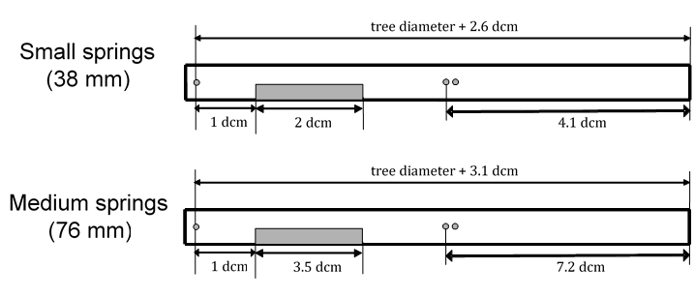
Figure 3. Metal dendrometer band size, hole locations, and window locations. Note that “dcm” stands for the measurements in cm on the diameter tape, each of which is actually equal to 3.14 cm.

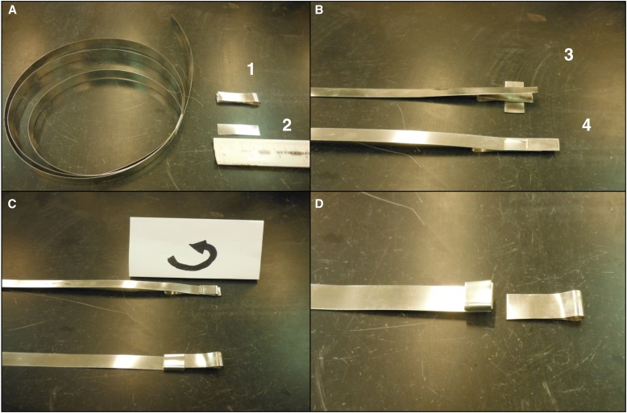Figure 4. Creation of metal dendrometer band collar. Reprinted from Anemaet, Evelyn R., and Beth A. Middleton. “Dendrometer Bands Made Easy: Using Modified Cable Ties to Measure Incremental Growth of Trees.”Applications in Plant Sciences 1.9 (2013): apps.1300044. PMC. Web. 20 Apr. 2015.

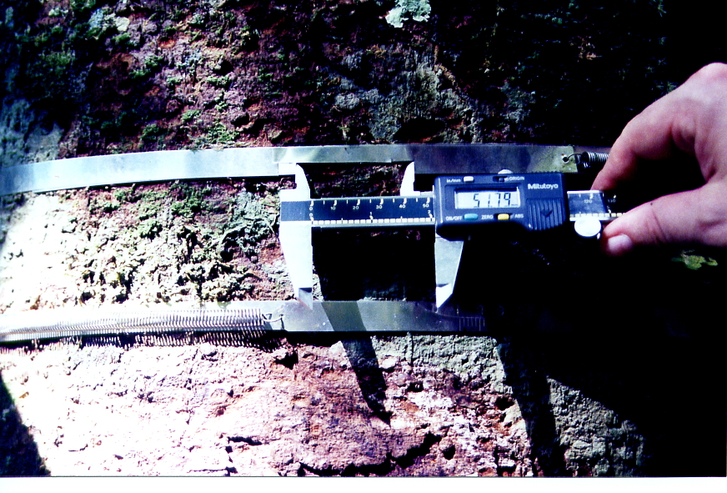
Figure 5: Picture of two band dendrometers (one above the other), and measurement of the window size of one of the dendrometers with calipers.

If using plastic dendrometers
- Cut a length of banding equal to c + 4 t + 6.5 dcm, where c is the circumference of the tree, t is length of a metal seal, and s is length of spring when not stretched (Figure XX).
- Attach the seals to folded over banding as shown in Figure XX (see Figure XX for an image of the finished product). Note that the loops to attach the spring should be approximately 0.5 dcm long, the shorter tail should be s long, and the longer tail should be 6 dcm long. The smooth side of the seal should be towards the trunk to minimize friction.
- Cut a small notch 1dcm from the seal in the longer tail (Figure XX). The depth of the notch should be approximately 10-20 % of the width of the band and the side closer to the seal should be cut vertically. For dendrometers installed below the eye level the notch should be on the top of the band; for those installed higher up, it should be on the bottom.
- Cut the corners of the loops to enable attachment of the spring (Figure XX).
- Install the dendrometer band so that the notch is appropriately positioned (on top for bands installed below eye level; on the bottom for bands installed above eye level).
- Check that the band is level and goes under lianas and epiphyte roots, and adjust it if necessary.
- Make sure that throughout the area where the band is doubled, it sits snugly against the trunk (that is, there are no air spaces between the band and the trunk in this area). Rotate the band around the trunk if necessary.
- Carefully take up slack in the band as much as possible so that the band sits tightly around the trunk.
- Check that the spring is a little bit stretched (approximately 0.5 dcm longer than its resting length) and that the distance from the notch to the tip of the shorter tail is approximately 0.5 dcm.
- Optional – Paint the seals and the bark of the tree above and below the seals. This makes it easy to see if there is any change in the location of the band, and can be used to camouflage the band (and protect it from theft) if the paint is similar in color to the bark.
- Use the digital calipers to measure the distance between the end of the shorter tail and the notch (Figure 5). Record on the datasheet. (Make sure the caliper is set to read in mm.)
Notch
Measured with a caliper
t
0.5 dcm
s + streching
t
0.5 dcm
Seal
Spring
Band

Figure 6. Schematic representation of a plastic dendrometer installed around a tree, seen from above. s is the length of the spring when not stretched; t is the length of the seal.

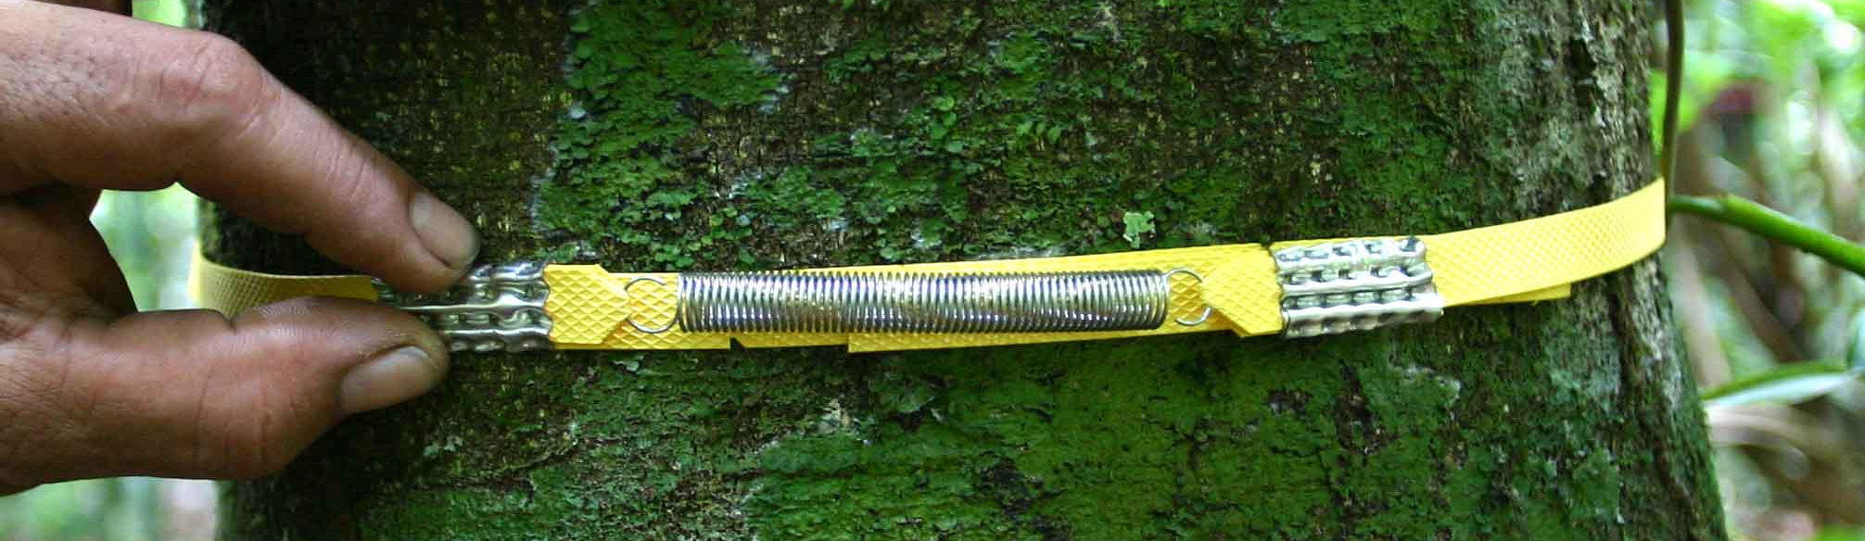
Figure 7: Plastic dendrometer installed on a tree. Note that the seals look quite different when fastened. The spring is attached between folded over parts of bands, with both ends of each fold cut. The notch in the lower band and the free end of the upper band are both visible beneath the spring.

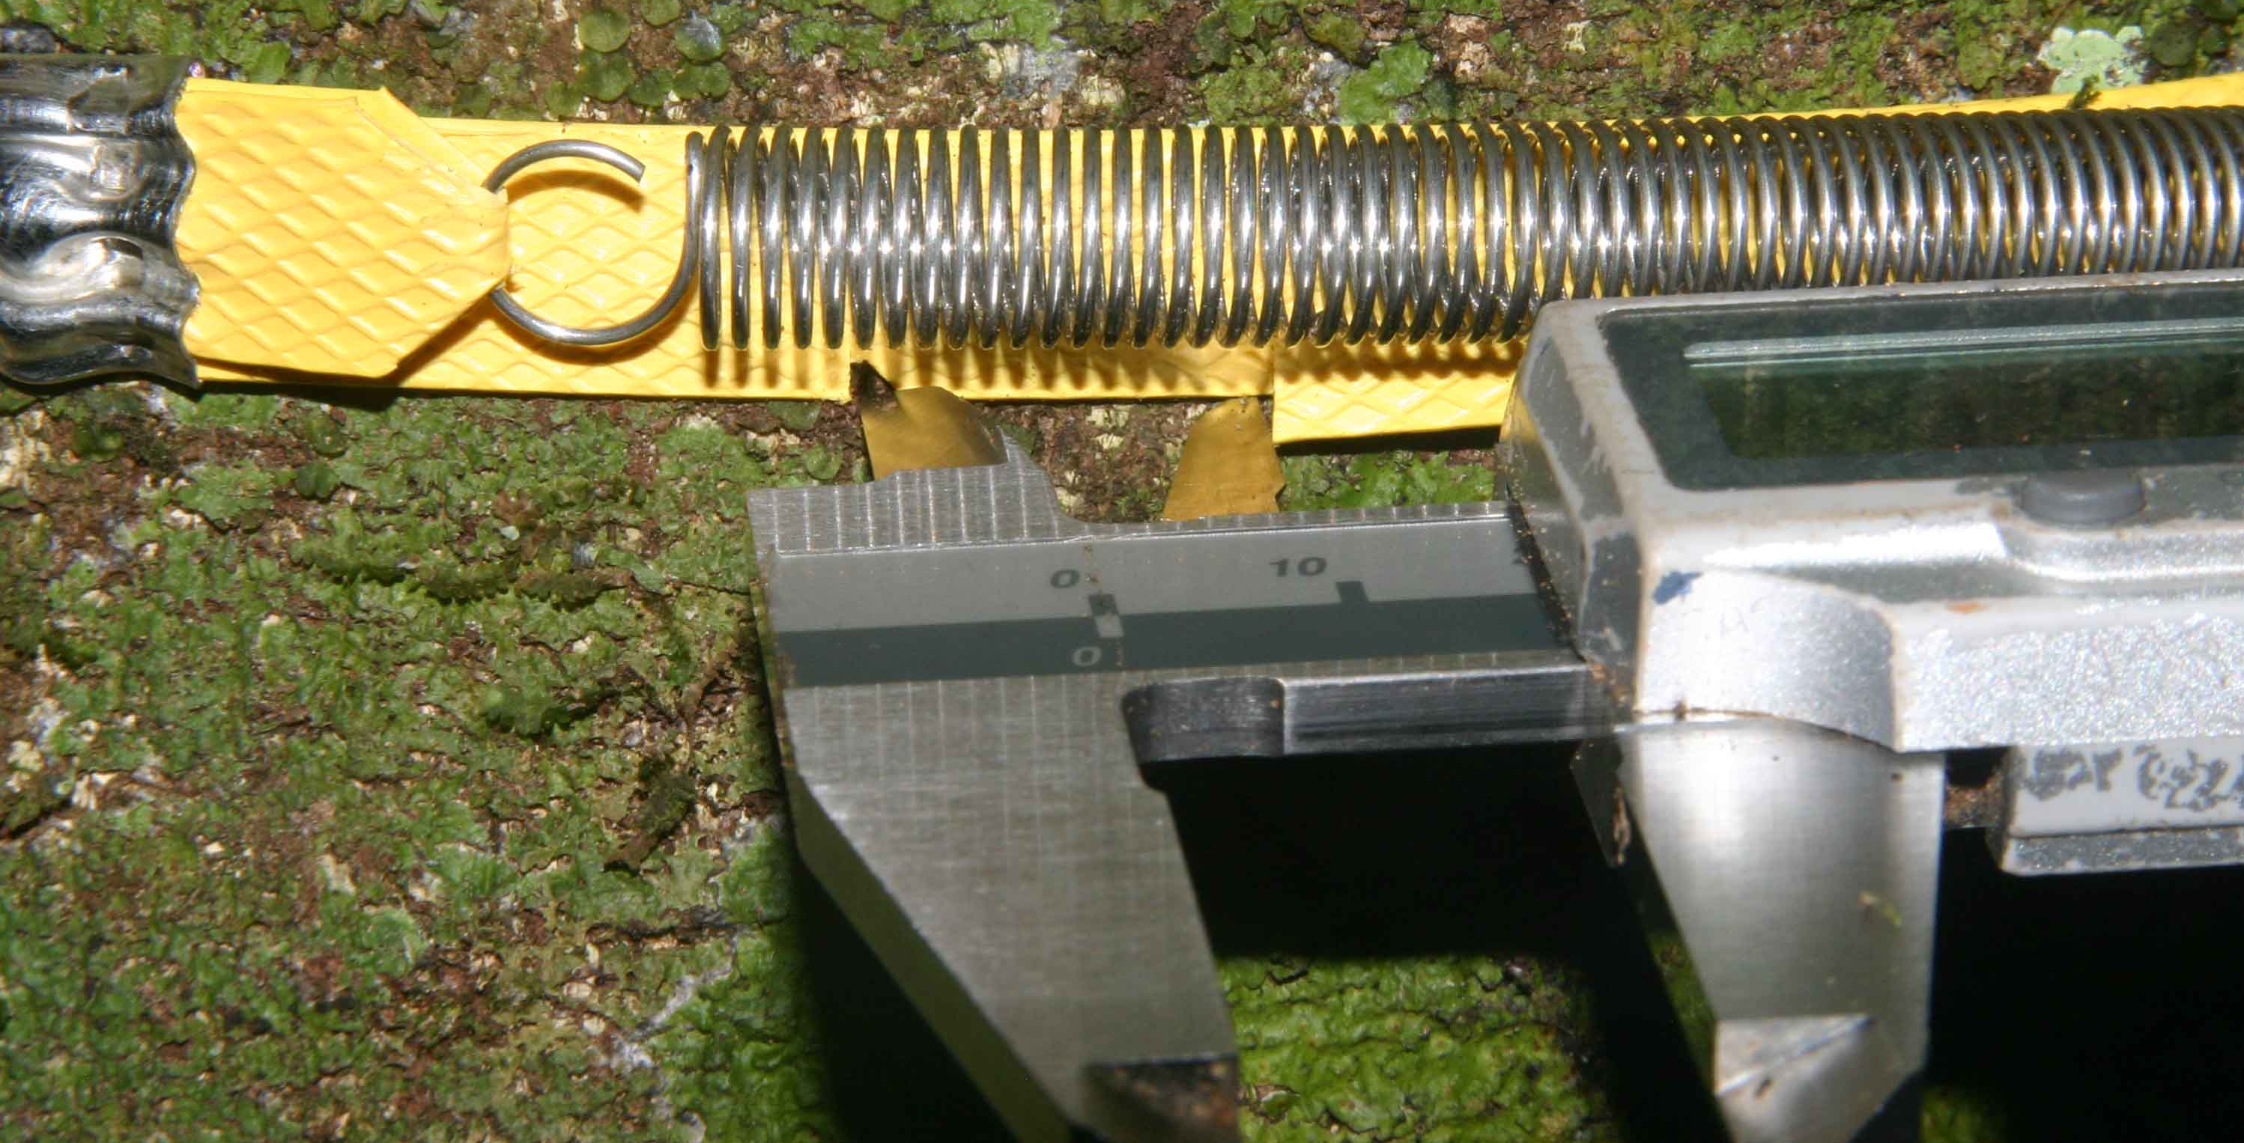
Figure 8: The caliper measurement is made from the notch on the lower band to the free end of the upper band.

Dendrometer remeasurement

- Locate the designated tree using the information on the maps and datasheet.
- Make Tree Status Observations exactly as for the initial dendrometer installation. (If the dendrometers are being recensused multiple times per year, then the choice can be made to do a full set of observations only once per year, and a reduced set at the time of other remeasurements.)
- Evaluate the state of the band dendrometer: is the dendrometer still in good condition to be measured as is? If it has shifted out of position but can easily be readjusted and the previous location is clear, then make the adjustment and consider it in good condition for measurement. If it has broken or if it has been shifted out of position in such a way that it cannot easily be readjusted or the previous band location is unclear, then it is NOT in good condition for remeasurement.
  - IF the dendrometer is in good condition
    - Record dendrometer observations as appropriate.
    - Remeasure the window size with calipers and record it in the datasheet.
  - IF the dendrometer is not in good condition to be measured as is, then
    - Make a note regarding the problem with the previous dendrometer, and record any relevant codes for that dendrometer
    - If the band can be placed back on the tree in a good position, then place the band on the tree again and treat this as a new dendrometer record. Record the code JX for “band moved” on the existing data sheet. Change the dendrometer # written on the dendrometer using permanent marker (increase the dendrometer number by 1). Use the “Band Replacement” datasheet and fill out all fields, including assigning the new dendro number.
    - If the band cannot be placed back on the tree in a good position, then either construct a new band in the field at this time, or make a note to come back and install a new band later (measure the diameter at the band location if the plan is to construct he band in the lab). When installing a new band, follow instructions under “Replacing bands” below.
  - Evaluate if it is time to replace the dendrometer. Has the tree grown such that there already is a gap between the two ends of the bands, or soon will be a gap? In this case, either construct a new band in the field at this time, or make a note to come back and install a new band later(measure the diameter at the band location if the plan is to construct he band in the lab). When installing a new band, follow instructions under “Replacing bands” below.
- Replacing bands. When a band needs to be replaced, use the “Band Replacement” data sheet. This should be done only when the new band is available for installation. (Depending on site conditions, it may be preferable to construct new bands in the lab, using the recorded diameter installation, and then bring them to the field for installation.
  - Record the tag number of the tree. Doublecheck it for accuracy!
  - If a previous band is still on the tree and in good condition,
    - record its dendro number
    - measure and record its window size
    - record any relevant dendrometer codes
    - use a permanent marker to mark the location of the band on the tree
    - remove the old band
    - measure and record the diameter at the location of the old dendrometer band
  - Designate a new dendro number for the new band, equal to the number of the old band plus one.
  - Evaluate if the previous dendrometer location remains a suitable location for a dendrometer. If buttresses have grown up into or within 0.5 m of the band, and if the buttresses have a clear top, then the new band should be at least 0.5 m and preferably 1 m above the tops of the buttresses.
  - If the new dendrometer will be installed in the same location as the old dendrometer, then write “SAME” under dendrometer height.
  - Measure and record the diameter at the point of dendrometer installation (if it was just measured in connection with the old dendrometer, then write “SAME”).
  - Construct, install, and measure a new band following instructions under “Dendrometer construction” above, including writing the tag # and dendro # on the band in permanent marker.

Table 1: List and definition of all codes used in the dendrometer census.

Code | Note
Dead tree codes
DS | Dead trunk still standing
DC | Dead trunk lying on ground
DT | Tree missing, tag found
DN | Tree and tag both missing
Tree condition codes
M | Multiple stems
R | Resprout from a break below 1.3 m
Q | Stem broken above 1.3 m
B | Buttresses extending to 1 m or higher
I | Irregular stem
L | Stem leaning more than X degrees
Codes related to diameter and dendrometer measurements
VW | Lianas/epiphytes under dbh tape
VU | Lianas/epiphytes under dendrometer
VO | Lianas/epiphytes OVER dendrometer, tape
JY | Bark peeling near/under band
JX | Band moved

